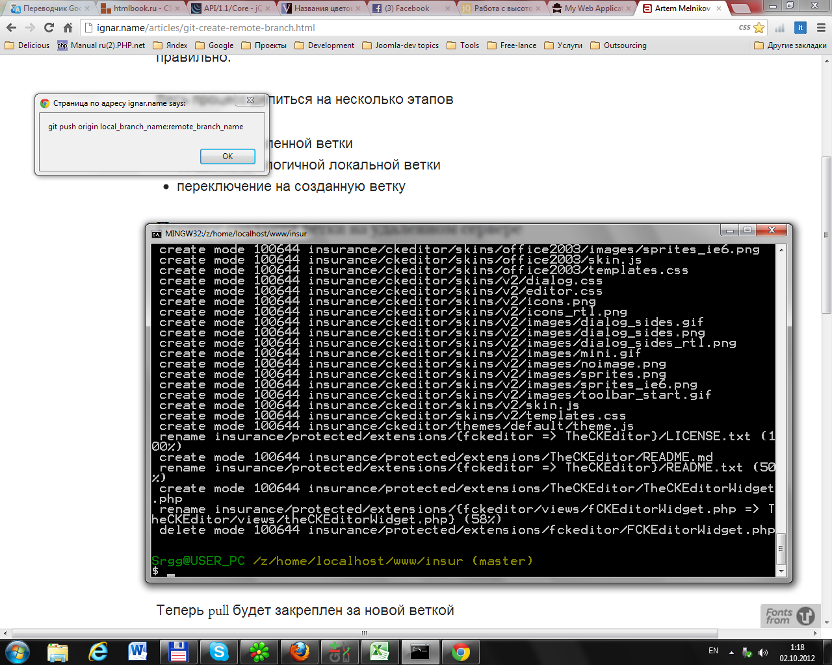

PHP warning

copy(Z:\home\localhost\www\insur\insurance\assets\112c02fe\img\_notes\dwsync.xml) [<a href='function.copy'>function.copy</a>]: failed to open stream: Permission denied

**Z:\home\localhost\www\insur\yii\framework\utils\CFileHelper.php(130)**

118 @chmod($dst,0777);

119 $folder=opendir($src);

120 while(($file=readdir($folder))!==false)

121 {

122 if($file==='.' || $file==='..')

123 continue;

124 $path=$src.DIRECTORY_SEPARATOR.$file;

125 $isFile=is_file($path);

126 if(self::validatePath($base,$file,$isFile,$fileTypes,$exclude))

127 {

128 if($isFile)

129 {

**130** copy($path,$dst.DIRECTORY_SEPARATOR.$file);

131 if(isset($options['newFileMode']))

132 @chmod($dst.DIRECTORY_SEPARATOR.$file, $options['newFileMode']);

133 }

134 else if($level)

135 self::copyDirectoryRecursive($path,$dst.DIRECTORY_SEPARATOR.$file,$base.'/'.$file,$fileTypes,$exclude,$level-1,$options);

136 }

137 }

138 closedir($folder);

139 }

140

141 /**

142 * Returns the files found under the specified directory and subdirectories.

Stack Trace

|  |  |
| --- | --- |
| #0 | +    Z:\home\localhost\www\insur\yii\framework\utils\CFileHelper.php(130): **copy**("Z:\home\localhost\www\insur\insurance\protected\extensions\boots...", "Z:\home\localhost\www\insur\insurance\assets\112c02fe\img\_notes...") |
| #1 | +    Z:\home\localhost\www\insur\yii\framework\utils\CFileHelper.php(135):**CFileHelper**::**copyDirectoryRecursive**("Z:\home\localhost\www\insur\insurance\protected\extensions\boots...", "Z:\home\localhost\www\insur\insurance\assets\112c02fe\img\_notes", "/img/_notes", array(), ...) |
| #2 | +    Z:\home\localhost\www\insur\yii\framework\utils\CFileHelper.php(135):**CFileHelper**::**copyDirectoryRecursive**("Z:\home\localhost\www\insur\insurance\protected\extensions\boots...", "Z:\home\localhost\www\insur\insurance\assets\112c02fe\img", "/img", array(), ...) |
| #3 | +    Z:\home\localhost\www\insur\yii\framework\utils\CFileHelper.php(59):**CFileHelper**::**copyDirectoryRecursive**("Z:\home\localhost\www\insur\insurance\protected\extensions\boots...", "Z:\home\localhost\www\insur\insurance\assets\112c02fe", "", array(), ...) |
| #4 | +    Z:\home\localhost\www\insur\yii\framework\web\CAssetManager.php(248):**CFileHelper**::**copyDirectory**("Z:\home\localhost\www\insur\insurance\protected\extensions\boots...", "Z:\home\localhost\www\insur\insurance\assets\112c02fe", array("exclude" => array(".svn", ".gitignore"), "level" => -1, "newDirMode" => 511, "newFileMode" => 438)) |
| #5 | –    Z:\home\localhost\www\insur\insurance\protected\extensions\bootstrap\components\Bootstrap.php(328): **CAssetManager**->**publish**("Z:\home\localhost\www\insur\insurance\protected\extensions\boots...", false, -1, true)  323 if (isset($this->_assetsUrl))  324 return $this->_assetsUrl;  325 else  326 {  327 $assetsPath = Yii::getPathOfAlias('bootstrap.assets');  **328** $assetsUrl = Yii::app()->assetManager->publish($assetsPath, false, -1, YII_DEBUG);  329 return $this->_assetsUrl = $assetsUrl;  330 }  331 }  332  333 /** |
| #6 | –    Z:\home\localhost\www\insur\insurance\protected\extensions\bootstrap\components\Bootstrap.php(124): **Bootstrap**->**getAssetsUrl**()  119 * Registers the Yii-specific CSS missing from Bootstrap.  120 * @since 0.9.11  121 */  122 public function registerYiiCss()  123 {  **124** Yii::app()->clientScript->registerCssFile($this->getAssetsUrl().'/css/bootstrap-yii.css');  125 }  126  127 /**  128 * Registers the core JavaScript.  129 * @since 0.9.8 |
| #7 | –    Z:\home\localhost\www\insur\insurance\protected\extensions\bootstrap\components\Bootstrap.php(90): **Bootstrap**->**registerYiiCss**()  85  86 if ($this->responsiveCss !== false)  87 $this->registerResponsiveCss();  88  89 if ($this->yiiCss !== false)  **90** $this->registerYiiCss();  91  92 if ($this->enableJS !== false)  93 $this->registerCoreScripts();  94  95 parent::init(); |
| #8 | +    Z:\home\localhost\www\insur\yii\framework\base\CModule.php(388): **Bootstrap**->**init**() |
| #9 | +    Z:\home\localhost\www\insur\yii\framework\base\CModule.php(493): **CModule**->**getComponent**("bootstrap") |
| #10 | +    Z:\home\localhost\www\insur\yii\framework\base\CApplication.php(146): **CModule**->**preloadComponents**() |
| #11 | +    Z:\home\localhost\www\insur\yii\framework\YiiBase.php(128): **CApplication**->**__construct**("Z:\home\localhost\www\insur\insurance/protected/config/local.php") |
| #12 | +    Z:\home\localhost\www\insur\yii\framework\YiiBase.php(101): **YiiBase**::**createApplication**("CWebApplication", "Z:\home\localhost\www\insur\insurance/protected/config/local.php") |
| #13 | +    Z:\home\localhost\www\insur\insurance\index.php(18): **YiiBase**::**createWebApplication**("Z:\home\localhost\www\insur\insurance/protected/config/local.php") |

2012-10-01 23:47:03 Apache/2.2.4 (Win32) mod_ssl/2.2.4 OpenSSL/0.9.8k PHP/5.3.3 [Yii Framework](http://www.yiiframework.com/)/1.1.11